**A Project Report**

**On**

**“Ratio Analysis Of ACC Ltd.”**

**SUBMITTED TO HP UNIVERSITY SHIMLA**



IN PARTIAL FULFILLMENT OF THE REQUIREMENT FOR THE AWARD OF THE DEGREE

OF

BACHELOR OF BUSINESS ADMINISTRATION

SESSION 2021-22

IN SWAMI VIVEKANANDA GOVT. COLLEGE GHUMARWIN

**SUPERVISOR: SUBMITTED BY:**

**Mr. Naresh Kumar Sunaina Sharma**

**ASSTT. PROF. (BBA) BBA 6th sem.**

**Roll. No. 5190350031**

**ACKNOWLEDGMENT**

“Acknowledgement is an art, one can write glib stanzas without meaning a word, on other hand one can make a simple expression of gratitude” I take the opportunity to express my gratitude to all of them who in some or other way helped me to accomplish this challenging training in “ **ACC Ltd. (HP)”** no amount of written expression is sufficient to show my deepest sense of reference to Principal Mr. Ramkrishan Bharti, Co-ordinator Asst. Prof. Rajender Kumar and Asst. Prof. Naresh Kumar (Project Guide). I also express deepest gratitude to my family for their blessing and good wishes.

I also acknowledge with a deep sense of reverence, my gratitude towards my parents and my friends who directly or indirectly help me.

Sunaina Sharma

**CERTIFICATE**

This is to certify that the Project report entitled **“Ratio Analysis”** for the award of the degree of Bachelor of Business Administration (**BBA**) from **Swami Vivekananda Govt. Degree College Ghumarwin (H.P.)**, is a record of project report carried out by **Sunaina Sharma BBA 6th Sem., Roll No-5190350031,** under my Supervision and guidance, no part of this report has been submitted to any other Degree/Diploma and this report may be taken for evaluation.

.

Sign Of candidate Sign of Guide

Sign. Of coordinator (BBA)

DATE:

PLACE:

**DECLARATION**

I **Sunaina Sharma** hereby declare that the project report was submitted by me under the supervision and guidance of **Asst.** **Prof. Naresh** **Kumar**, project guide college of **S.V.G.C.** **GHUMARWIN** in partial fulfilment of BBA 6th semester. I further declare that I am solely responsible for omission and commission of errors if any.

Signature

**Sunaina Sharma**

University Roll no. 5190350031

DATE -

**TABLE OF CONTENT**

|  |  |  |
| --- | --- | --- |
| **INDEX** | | |
| **SR.NO.** | **CONTENTS** | **PAGE NO.** |
| **Chapter 1.** | **Introduction to the topic**  **Introduction to organization** | **1-26** |
| **Chapter 2.** | **Review of Literature** | **27-28** |
| **Chapter 3.** | **Research methodology**   * **Need and scope of study** * **Objectives of study** * **Limitations** | **29-30** |
| **Chapter 4.** | **Data Analysis and**  **interpretation** | **31-46** |
| **Chapter 5.** | **Findings And Suggestions**   * **Findings** * **Suggestions** | **47-49** |
|  | **Bibliography**   * **References** * **Websites** | **50** |
|  | **Balance Sheet** | **51-53** |

**CHAPTER -1**

INTRODUCTION TO THE TOPIC

INTRODUCTION TO ORGANIZATION

**INTRODUCTION TO THE TOPIC**

**Ratio analysis** is a powerful tool of financial analysis. A ratio is defined as “the indicated quotient of two mathematical expressions” and “the relationship between two or more things”. In financial analysis, a ratio is used as a benchmark for evaluation of the financial position and performance of a firm. The absolute accounting figures reported in the financial statements do not provide a meaningful understanding of the performance and financial position of a firm. An accounting figure conveys meaning when it is related to some other relevant information. For example, an Rs.5 cr. net profit may look impressive, but the firm’s performance can be said to be good or bad only when the net profit figure is related to the firm’s Investment.

The relationship between two accounting figures expressed mathematically, is known as a financial ratio (or simply as a ratio). Ratios help to summarize large quantities of financial data and to make qualitative judgment about the firm’s financial performance. For example, consider current ratio. It is calculated by dividing current assets by current liabilities; the ratio indicates a quantified relationship between current assets and current liabilities. This relationship is an index or yardstick, which permits a quantitative judgment to be formed about the firm’s liquidity and vice versa. The point to note is that a ratio reflecting a quantitative relationship helps to form a qualitative judgment. Such is the nature of all financial ratios.

**Standards of comparison:**

The ratio analysis involves comparison for a useful interpretation of the financial statements. A single ratio in itself does not indicate favorable or unfavorable condition. It should be compared with some standard. Standards of comparison may consist of:

* **Past ratios**, i.e. ratios calculated from the past financial statements of the same firm;
* **Competitors’ ratios**, i.e., of some selected firms, especially the most progressive and successful competitor, at the same pint in time;
* **Industry ratios**, i.e. ratios of the industry to which the firm belongs;
* **Protected ratios,** i.e., developed using the protected or Performa financial statements of the same firm.

**Use and significance of ratio analysis**

The ratio is one of the most powerful tools of financial analysis. It is used as a device to analyze and interpret the financial health of enterprise. Ratio analysis stands for the process of determining and presenting the relationship of items and groups of items in the financial statements. It is an important technique of the financial analysis. It is the way by which financial stability and health of the concern can be judged. Thus ratios have wide applications and are of immense use today. The following are the main points of importance of ratio analysis:

**a) Managerial uses of ratio analysis:-**

**1. Helps in decision making:-**

Financial statements are prepared primarily for decision-making. Ratio analysis helps in making decision from the information provided in these financial Statements.

**2. Helps in financial forecasting and planning:-**

Ratio analysis is of much help in financial forecasting and planning. Planning is looking ahead and the ratios calculated for a number of years a work as a guide for the future. Thus, ratio analysis helps in forecasting and planning.

**3. Helps in communicating:-**

The financial strength and weakness of a firm are communicated in a more easy and understandable manner by the use of ratios. Thus, ratios help in communication and enhance the value of the financial statements.

**4. Helps in co-ordination:-**

Ratios even help in co-ordination, which is of at most importance in effective business management. Better communication of efficiency and weakness of an enterprise result in better co-ordination in the enterprise.

**5. Helps in control:-**

Ratio analysis even helps in making effective control of business. The weaknesses are otherwise, if any, come to the knowledge of the managerial, which helps, in effective control of the business.

**b) Utility to shareholders/investors:-**

An investor in the company will like to assess the financial position of the concern where he is going to invest. His first interest will be the security of his investment and then a return in form of dividend or interest. Ratio analysis will be useful to the investor in making up his mind whether present financial position of the concern warrants further investment or not.

## c) Utility to creditors: -

The creditors or suppliers extent short-term credit to the concern. They are invested to know whether financial position of the concern warrants their payments at a specified time or not.

**d) Utility to employees:-**

The employees are also interested in the financial position of the concern especially profitability. Their wage increases and amount of fringe benefits are related to the volume of profits earned by the concer.

**e) Utility to government:-**

Government is interested to know overall strength of the industry. Various financial statement published by industrial units are used to calculate ratios for determining short term, long-term and overall financial position of the concerns.

**f) Tax audit requirements:-**

Sec44AB was inserted in the income tax act by financial act; 1984.Caluse 32 of the income tax act requires that the following accounting ratios should be given:

* + 1. Gross profit/turnover.
    2. Net profit/turnover.
    3. Stock in trade/turnover.
    4. Material consumed/finished goods produced

Further, it is advisable to compare the accounting ratios for the year under consideration with the accounting ratios for earlier two years so that the auditor can make necessary enquiries, if there is any major variation in the accounting ratios.

**Limitations OF RATIO ANALYSIS**

Ratio analysis is very important in revealing the financial position and soundness of the business. But, inspite of its advantages, it has some limitations which restrict its use. These limitations should be kept in mind while making use of ratio analysis for interpreting the financial the financial statements. The following are the main limitations of ratio analysis:

**1. False results:-**

Ratios are based upon the financial statement. In case financial statements are in correct or the data of on which ratios are based is in correct, ratios calculated will all so false and defective. The accounting system it self suffers from many inherent weaknesses the ratios based upon it cannot be said to be always reliable.

**2. Limited comparability:-**

The ratio of the one firm cannot always be compare with the performance of other firm, if uniform accounting policies are not adopted by them. The difference in the methods of calculation of stock or the methods used to record the deprecation on assets will not provide identical data, so they cannot be compared.

**3. Price level changes affect ratios:-**

The comparability of ratios suffers, if the prices of the commodities in two different years are not the same. Change in price effect the cost of production, sale and also the value of assets. It means that the ratio will be meaningful for comparison, if the prices do not change.

**4. Ignoring qualitative factors:-**

Ratio analysis is the quantitative measurement of the performance of the business. It ignores qualitative aspect of the firm, how so ever important it may be. It shows that ratio is only a one sided approach to measure the efficiency of the business.

**5. Window dressing**:-

Financial statements can easily be window dressed to present a better picture of its financial and profitability position to outsiders. Hence, one has to be very carefully in making a decision from ratios calculated from such financial statements.

**6. Absolute figures distortive:-**

Ratios devoid of absolute figures may prove distortive, as ratio analysis is primarily a quantitative analysis and not a qualitative analysis.

**Classification of ratios**

Several ratios, calculated from the accounting data can be grouped into various classes according to financial activity or function to be evaluated. Mangement is interested in evaluating every aspect of the firm’s performance. They have to protect the interests of all parties and see that the firm grows profitably. In view of thee requirement of the various users of ratios, ratios are classified into following four important categories:

* **Liquidity ratios** - short-term financial strength
* **Leverage ratios** - long-term financial strength
* **Profitability ratios** - long term earning power
* **Activity ratios** - term of investment utilization

**Liquidity ratios** measure the firm’s ability to meet current obligations;

**Leverage ratios** show the proportions of debt and equity in financing the firm’s assets;

**Activity ratios** reflect the firm’s efficiency in utilizing its assets; and

**Profitability ratios** measure overall performance and effectiveness of the firm.

**LIQUIDITY RATIOS:**

It is extremely essential for a firm to be able to meet the obligations as they become due. **Liquidity ratios** measure the ability of the firm to meet its current obligations (liabilities). The liquidity ratios reflect the short-term financial strength and solvency of a firm. In fact, analysis of liquidity needs the preparation of cash budgets and cash and funds flow statements; but liquidity ratios, by establishing a relationship between cash and other current assets to current obligations, provide a quick measure of liquidity. A firm should ensure that it does not suffer from lack of liquidity, and also that it does not have excess liquidity. A very high degree of liquidity is also bad; idle assets earn nothing. The firm’s funds will be unnecessarily tied up in current assets. Therefore, it is necessary to strike a proper balance between high liquidity and lack of liquidity.

The most common ratios which indicate the extent of liquidity are lack of it, are:

1. **Current ratio**
2. **Quick ratio**
3. **Cash ratio**

### Current Ratio

Current ratio may be defined as the relationship between current assets and current liabilities. This ratio is also known as working capital ratio. It is a measure of general liquidity and is the most widely used to make the analysis of short term financial or liquidity of a firm. It is calculated by dividing the total current assets by total current liabilities and the ideal current ratio is 2:1. It is calculated as follows a firm.

Current Ratio = Current assets/ Current liabilities.

The higher the current ratio, the greater the firm's ability to meet the short term debts. A very high current ratio indicates too much of money is blocked in current assets etc. In short a very high current ratio indicates that the firm will find it difficult to pay off its debts.

### Quick Ratio

the term liquidity ratio refers to the ability of a firm to pay off its short term obligations as and when they become due Cash in hand and cash at bunk are the most liquid asset. The other assets included in the liquid assets are bills receivables, sundry debtors, marketable and short term or tempory investments. The Ideal liquid or quick ratio is 1:1. The liquid ratio can be calculated as follows.

Quick ratio = Liquid assets/Current liabilities

Quick Assets Current Assets - (stock + prepaid expenses)

Liquid ratio is considered to be superior to current ratio in testing the liquidity position of a firm. If the current ratio is 2:1 and quick ratio is 1:1; the liquidity position may be considered satisfactory. If the current ratio is higher than 2:1, but quick ratio is less than 1:1, it indicates excessive inventory.

### Absolute Liquid Ratio or Cash Ratio

This ratio establishes the relationship between super quick assets and quick liabilities. And it is taken as a ratio of absolute liquid assets or absolute quick assets includes cash in hand, cash at bank and marketable securities or short term investments. It is also known as cash ratio. And ideal absolute liquid ratio is 0.5:1.

Absolute Liquid Ratio = Absolute Liquid Assets/Current Liabilities.

### Solvency Ratio

Solvency ratio is one of the various ratios used to measure the ability of a company to meet its long term debts. Solvency ratio is also called leverage ratio. It focuses on the long term sustainability of a company instead of the current liability payments.

### Proprietary Ratio

Proprietary ratio establishes the relationship between shareholders or proprietors fund and total assets. This ratio shows how much funds have been contributed by shareholders in the total assets of the firm. Proprietary ratio is also known as equity ratio or net worth ratio. It is computed as follows:

Proprietary Ratio - Shareholders fund/Total assets.

This ratio shows financial health of the firm. A high ratio indicates safety to the creditors and low ratio shows greater risk to the creditors. The ideal ratio is 0.5:1 or above.

### Debt Equity Ratio

Debt equity ratio is the most commonly used ratio to test solvency of a firm. This ratio indicates the relative proportion of debt and equity in financing the assets of a firm.

Debt Equity Ratio=Long term debt/ equity

### Profitability Ratios

The ultimate aim of any business enterprise is to earn maximum profit. To the management, profit is the measure of efficiency and control. Profitability ratio measures the ability of the firm to earn an adequate return on sales, total assets and invested capital. There are two types of profitability ratios. First, profitability based on sales and it includes gross profit ratio, orating ratio, operating profit ratio and net profit ratio. Second, profitability ratio based on investment and it includes return on investment, return on shareholders fund ratio, return on equity ratio and return on total assets. Profit is important for everyone associated with the company including creditors and owners.

### Net Profit Ratio

Net profit ratio is the ratio of net profits to revenues for accompany or business segment. It measures the overall profitability. Net profit and net sales are the two components of net profit ratio. Net profit is the final profit after adjusting all expenses and all incomes. The main objectives of the ratio are to measure the overall profitability. This ratio indicates how much of the sales are left where meeting expenses. The ideal net profit ratio is 5% – 10%

Net profit ratio =Net Profit /Net sales*100

Net profits can be taken as profit before tax and profits after tax. Higher the ratio, better is the profitability,

**Return on Equity**

The return on equity (ROE) is a measure of the profitability of a business in relation to the [equity](https://en.wikipedia.org/wiki/Equity_(finance)). Because shareholder's equity can be calculated by taking all assets and subtracting all liabilities, ROE can also be thought of as a return on assets minus liabilities. ROE measures how many dollars of profit are generated for each dollar of shareholder's equity. ROE is a metric of how well the company utilizes its equity to generate profits.

Return on equity = net profit / equity share capital

### Earnings per share

Earnings per share (EPS) is the monetary value of [earnings](https://en.wikipedia.org/wiki/Earnings) per [outstanding](https://en.wikipedia.org/wiki/Outstanding_share) share of [common stock](https://en.wikipedia.org/wiki/Common_stock) for a company.

Earnings per share = net profit / no. of Shares

### Activity ratios

Activity ratios measure how quickly a firm converts non-cash assets to cash assets. Debt ratios measure the firm's ability to repay long-term debt.

### Working Capital Turnover Ratio

This ratio indicates the number of times working capital is turned over during a year. It also signifies the efficiency of management on the use of current or short term resources of a firm.

Working capital turnover ratio= Net sales/Working capital. (Working capital= Current assets-Current liabilities).

### Total Assets Turnover Ratio

This ratio is the ratio between the value of a company’s sales or revenues and the value of its total assets. This ratio helps the investors to understand how effectively companies are using their assets to generate sales.

Total asset turnover ratio= Net sales/Total assets.

**INTRODUCTION TO THE ORGANIZATION**

**ACC**

**COMPANY PROFILE**

ACC Limited (ACC) is a leading player in the Indian building materials space, with a pan-India manufacturing and marketing presence. With 17 cement manufacturing units, 85 ready mix concrete plants, over 6,600 talented employees, a vast distribution network of 56,000 dealers & retailers and a countrywide spread of sales offices, it contributes tremendously to the landscape of the country.

For over 80 years, ACC has been synonymous with cement, establishing its reputation as a pioneer organization that consistently sets new benchmarks in research and innovative product development.

History was created more than eight decades ago when the doyens of the Indian cement industry unified their operations to build the foundation of a company that has only grown stronger with every passing year. From the Bhakra Nangal Dam in 1960 to the Mumbai-Pune Expressway, ACC cement is at the heart of iconic landmarks across the country.

Our success over the years can be attributed to our unrelenting focus on customer centricity, ethical business practices and sustainable development. We pay tribute to our motto of ‘Cementing Relationships’ with every single interaction with our range of stakeholders.

ACC’s brand architecture comprises the Gold range and Silver range of products assuring superior quality for general construction as well as for specialised applications and environments. The ready mix concrete product range provides one-stop solutions from basic requirements to high grades of concrete to build the country’s tallest structures.

Sustainability is an integral part of our business strategy, with our Sustainable Development 2030 Plan focused on four broad themes: Climate, Circular Economy, Water & Nature and People & Communities. Our corporate social responsibility efforts benefit local communities across the country by furthering economic and social progress. ACC’s earliest initiatives in community development date back to the 1940's – long before the term 'corporate social responsibility' was coined.

ACC was among the first Indian companies to include commitment to environmental protection as one of its corporate objectives. Since inception, we have integrated this commitment into all activities of our value chain, from mining to sales to promoting the use of alternative fuels and resources, resulting in one of the lowest carbon footprints in the cement industry.

In 2005, ACC became part of the lafarge Group of Switzerland. Subsequently, in 2015, and Lafarge came together in a merger to form Lafarge – the global leader in building materials and solutions. Being a part of this large group has fuelled ACC’s growth and the resultant technology sharing continues to help us stay ahead of the curve in the dynamic Indian market.

Since inception in 1936,The company has been a trendsetter and important benchmark for the cement industry in many areas of cement and concrete technology.

**Unique track:-**

ACC has a unique track record of innovative research, product development and specialized consultancy services.

**Manufacturing:-**

The company's various manufacturing units are backed by a central technology support services centre - the only one of its kind in the Indian cement industry.

Cement production cement cart transport network biggest customers Indian Railways.

ACC has rich experience in mining, being the largest user of limestone. As one of the largest cement producers in India, it is also among the biggest customers of the domestic coal industry, of Indian Railways, and a considerable user of the country’s road transport network services for inward and outward movement of materials and products.

**Board of Directors**

**ACC is a professionally managed company functioning under the overall supervision of the Board of Directors. The Board comprises Independent and Non-Independent Directors who are renowned professionals with diverse fields of expertise. They bring a wide range of skills and rich experience which enhances the quality of the direction and decision-making process.**

**The Board defines the long term vision for the Company and provides strategic oversight. It ensures that integrity, transparency, fairness, accountability, and compliance with the law are embedded in the Company’s business practices**



## Mr N S Sekhsaria

Non Executive and Non Independent Director

Mr Sekhsaria is the Chairman of the Board of Directors and a Non Independent and Non Executive Director. Mr Sekhsaria is a doyen of the Indian Cement Industry and one of the most respected business personalities in India.



## Mr Jan Jenisch

Non Executive and Non Independent Director

Jan Jenisch is Chief Executive Officer of Holcim.



## Mr Martin Kriegner

Non Executive and Non Independent Director

Mr Martin Kriegner is an Austrian national born in 1961, Mr Kriegner was appointed as Head of Asia Pacific andmember of the Group Executive Committee of Holcim in August 2016

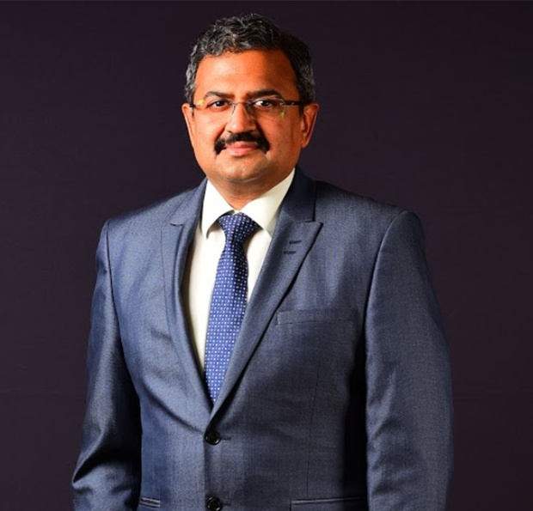

## Mr Sridhar Balakrishnan

Managing Director and Chief Executive Officer

Mr. Sridhar Balakrishnan is the Managing Director and Chief Executive Officer of ACC LimitedMr Balakrishnan's extensive leadership experience and expertise across markets make him a strong asset to the future growth strategy of the Company. Mr Balakrishnan has spent the majority of his career in the FMCG industry handling roles in sales, business finance and supply chain for India to managing P&L’s across international geographies

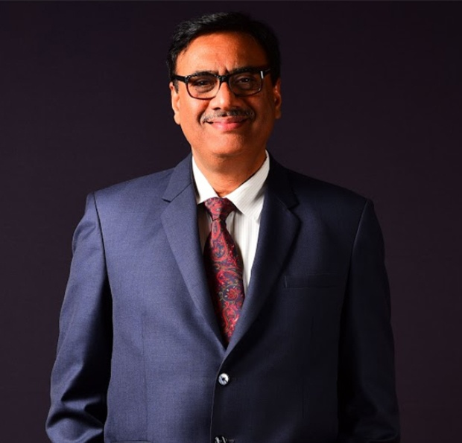

## Mr Neeraj Akhoury

Non-Executive, Non-Independent Director

Mr Neeraj Akhoury is Managing Director and Chief Executive Officer of Ambuja Cements Limited and the India CEO of LafargeHolcim.Since February 2020, he serves on the Board of ACC Limited as an Additional Director, Non-Executive, Non- Independent Director.

## Ms Falguni Nayar

Non Executive and Independent Director

Falguni Nayar is the Founder and Chief Executive Officer of Nykaa. Within a span of 9 years, Falguni has built one of India’s leading lifestyle focused consumer technology platforms right from scratch.



## Mr Vinayak Chatterjee

Non Executive and Independent Director

Born in 1959, Vinayak Chatterjee graduated in Economics (Hons) from St. Stephen's College, Delhi University (1976-1979) and did his MBA from the Indian Institute of Management.Ahmedabad (1979 – 1981). He co-founded Feedback Infra Pvt. Ltd. in 1990 and served as its Chairman from 1990 to 2021. Since stepping down from active management, he now devotes his time and energy to Infrastructure Policy and Advocacy; as well as to nurturing educational institutions.

.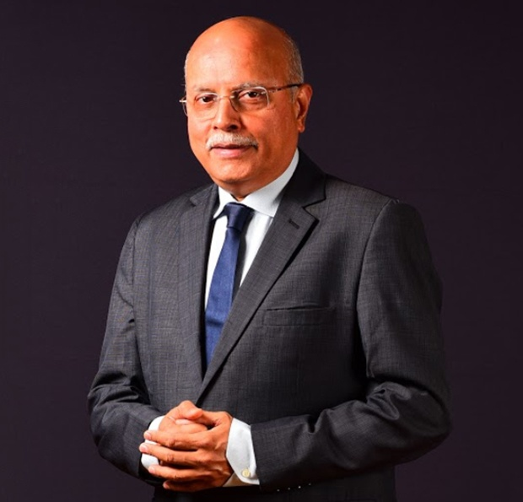

## Mr Shailesh Haribhakti

Non Executive and Independent Director

A man who has worn many hats in the corporate world & raised standards of various organizations so high, that people consider him as a serial Innovator, Pioneer, Teacher

Speaker, Author, Analyst, Entrepreneur & Citizen of the World (Vasudhaiva Kutumbakam). He is not only a Chartered & Cost Accountant, Certified Internal Auditor, a Certified Financial Planner, Fraud Examiner, but also a Board Chairman, Audit Committee Chairperson, and an Independent Director at some of the country's most pre-eminent organizations.

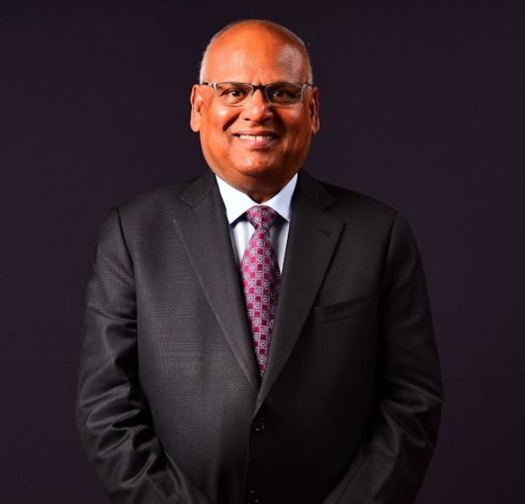

## Mr S K Roongta

Non Executive and Independent Director

Mr Roongta holds a Bachelor’s degree in Engineering from Birla Institute of Technology & Science (BITS), Pilani and a Post Graduate Diploma in Business Management - International Tradefrom the Indian Institute of Foreign Trade (IIFT), New Delhi. He is a Fellow of All India Management Association (AIMA) and Indian National Academy of Engineers (INAE).

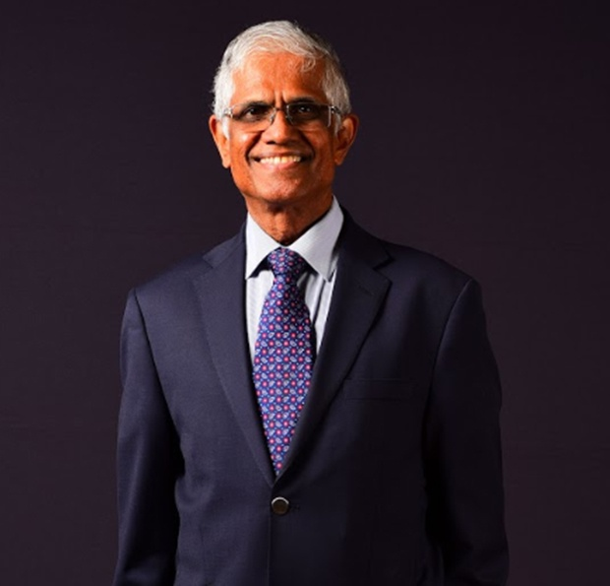

## Mr Damodarannair Sundaram

Non Executive and Independent Director

Mr Sundaram's experience spans corporate finance, business performance, monitoring operations, governance, mergers & acquisitions, talent / people management and strategyMr Sundaram joined Hindustan Unilever Limited (HUL), the Indian listed subsidiary of Unilever Plc, as a management trainee in June 1975 and served in various capacities including six years in Unilever, London as Commercial officer: Africa and Middle East (90-93) and as Sr. V.P for South Asia and Middle East (96-99). He was the Chief Finance Officer of HUL from April 99 to March 08 and as the Vice Chairman and CFO from April 08 to July 09. He is a two-time winner of the prestigious “CFO of the Year for FMCG Sector” award by CNBC TV18 (2006 and 2008). He was awarded as the 'Best Independent Director in 2019' by Asian Centre for Corporate Governance and Sustainability in December 2020.

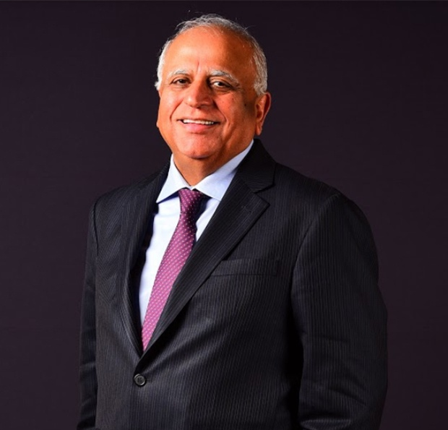

## Mr Sunil Mehta

Non Executive and Independent Director

Mr Sunil Mehta has over thirty-eight years of proven leadership experience in banking, financial services, insurance and investments with leading global and domestic financial institutions namely CitibankAIG, SBI, PNB and YES Bank amongst others. In 2013, he left AIG where he was the Country Head & CEO for AIG India since 2000. Subsequently, he started SPM Capital Advisers Pvt. Ltd. Mr Mehta is the Chairman and Managing Director of SPM Capital Advisers Pvt. Ltd., a leading boutique business advisory and consulting firm in India.

As Country Head & CEO for AIG in India, Mr Mehta was responsible for all AIG businesses in India covering Insurance, Financial Services, Real Estate and Investments amongst other businesses.



## Shri M.R.Kumar

Non Executive and Non Independent Director

Shri M.R.Kumar, took charge as Chairman, LIC of India on 14th March, 2019. He joined LIC of India in 1983 as a Direct Recruit Officer. In a career spanning more than three and a half decades,  he has had the unique privilege of heading three Zones of LIC of India , viz, Southern Zone, North Central Zone and Northern Zone, head quartered at Chennai, Kanpur and Delhi, respectively. His rich experience working pan India, in different Zones and in different streams of insurance management has given him a deep insight into the demographics and insurance potential of the country.

**CHAPTER 2.**

**Review Of Literature**

**REVIEW OF LITERATURE**

A review of past studies and theory relating to the problem of research helps not only definition of concepts. Problems focus, objectives and hypotheses, but also the choice of tools of analysis with attention to their assumption and limitations. The several past study related to cement industry and method of evaluating is performance and some of the reviews are:

**Petia (2004)** discuss in the study about performance of India’s non-financial corporate sector by using firm level data and evaluated its financial vulnerabilities. He has found that promising trends in liquidity. Profitability and leverage of the sector emerged in the early. He has experienced a reversal after1996. Nevertheless, most indicators were still at comfortable levels, and there was evidence of improvement in 2002. The study also revealed that a numbers of firms still face problems servicing their debt obligations, posing a risk to lenders. He has concluded that aggregate interest 37 coverage of the corporate sector indicated that potential non-performing loans of the corporate sector remain high and this underscores the need of the corporate sector remain high He suggested this underscores the need of close monitoring of the corporate sector in future.

**Jayant Snathaye (2005)** the study revealed that the Indian cement industry has grown rapidly over the past few decades and there have been significant investments in new cement kilns and associated production equipment. This has led to a situation where India’s cement industry in made up of both some of the world’s most energy-inefficient plants as well as some of the world’s best practice facilities. The challenge for the cement industry is to modernize or phase out the older, inefficient plants while acquiring the best possible cement production technology as production inevitably expands in the coming decades.

**CHAPTER 3.**

**Research Methodology**

**Need and Scope of Study**

**Objective of Study**

**Limitation**

**Need And Scope Of Study**

**Need of the study:**

The problems, which are common to most of the public sectors undertaking, are materials scarcity. Capacity utilization and mainly working capital requirements. Thus the importance of the study reveals as to how efficiently the working capital has been used so far in the organization.

**SCOPE OF THE STUDY**:

The scope of the study is limited to collecting financial data published in the annual reports of the company every year. The analysis is done to suggest the possible solutions. The study is carried out for 5 years (2017-21).

**Objectives of the study:**

* To examine the financial performance of the ACC Ltd. for the period of 2017 to 2021.
* To critically analyses the financial performance of the ACC Ltd. With Help of the ratios.

**Data sources:**

* The study is based on secondary data.
* Secondary data collected from annual reports and also existing manuals and like company records balance sheet and necessary records.

**LIMITATIONS**:

* The study is based on only secondary data.
* The period of study was 2017-21 financial years only.

**CHAPTER 4.**

**DATA ANALYSIS**

**AND**

**INTERPRETATION**

### Data Analysis and Interpretation

This chapter deals with the analysis ACC Limited and interprets the results based on the analysis. Data interpretation is the process of reviewing data through some predefined processes which will helps assign some meaning to the data and arrive at a relevant conclusion. It involves taking the result of data analysis, making inferences of the relations studied, and using them to conclude.

Ratio analysis is defined as systematic use of accounting ratios in order to evaluate the operating performance of a firm. According to j. Betty, “The term accounting ratio is used to describe the significant relationship which exists between figures of Balance sheet, Profit and loss account, in a budgetary control system or in any other part of the accounting organization”. Ratios can be expressed in times, percentages and proportion.

### Liquidity Ratio

Liquidity refers to the ability of a concern to meet its current obligation as and when these become due. The short term obligations are met by realizing amount from current, floating or circulating assets. The current assets should either be liquid or near to be liquidity. These should be convertible into cash for paying obligation of short term nature. The sufficiency or insufficiency of current asset should be assessed by comparing them with the current liabilities.

### Current Ratio

Current ratio may be defined as the relationship between current assets and current liabilities. The standard ratio is 2:1. This ratio is also known as working capital ratio, is a measure of general liquidity and is most widely used to make the analysis of a short term financial position or liquidity of a firm. It is calculated by dividing the total current asset by total current liabilitie

### Current Ratio= Current Asset/Current Liability

**Table 4.1** Table showing current asset, current liability and current ratio.

|  |  |  |  |
| --- | --- | --- | --- |
| Year | Current Asset  ( in rs .crore) | Current Liability  (In rs. crore ) | Current Ratio |
| 2020-2021 | 8448.63 | 4804.26 | 1.758 |
| 2019-2020 | 7534.57 | 4698.23 | 1.603 |
| 2018-2019 | 6684.44 | 4706.16 | 1.620 |
| 2017-2018 | 5654.92 | 4792.66 | 1.179 |
| 2016-2017 | 4069.64 | 4051.18 | 1.004 |

The above table shows the current ratio for five years. This ratio is used for analysing the liquidity or short term financial position of a firm. The standard ratio is 2:1. The table shows current ratio shows an increasing trend.

**Chart 4.1** Chart showing Current Ratio from 2017-2021.

**Quick Ratio:-**

Quick ratio is also termed as acid test or liquid ratio. It is supplementary to the current ratio. The acid test ratio is a more serve and stringent test of a firm’s ability to pay its short term obligation when they become due.

### Quick Ratio= Quick Asset/Current Liability

Quick Asset= Current Asset-Inventory-Prepaid expenses

**Table 4.2** Table showing Quick Asset, Current Liability and Quick Ratio

|  |  |  |  |
| --- | --- | --- | --- |
| Year | Quick Asset | Current Liability | Quick Ratio |
| 2020-2021 | 7492.11 | 4804.26 | 1.559 |
| 2019-2020 | 6350.32 | 4698.23 | 1.351 |
| 2018-2019 | 5005.05 | 4706.16 | 1.063 |
| 2017-2018 | 4250.14 | 4792.66 | 0.886 |
| 2016-2017 | 2845.01 | 4051.18 | 0.702 |

The above table shows quick ratio for five years. The standard ratio is 1:1.the table showing quick ratio is showing an increasing trend. Company met the standard ratio from the year 2019 – 2021.

**Chart 4.2** Chart showing Quick Ratio from 2017-2021.

### Absolute Quick Ratio

Absolute Quick Ratio is also known as Super Quick Ratio. This ratio establishes the relationship between the super quick asset and current liability.

### Absolute Quick Ratio= Super quick Asset/ Current Liability

Super Quick Asset= Cash +Marketable Securities

**Table 4.3** Table showing super quick asset, current liability and absolute quick ratio.

|  |  |  |  |
| --- | --- | --- | --- |
| Year | Super Quick Asset (in crore ) | Current Liability (in crore ) | Absolute Quick Ratio |
| 2020-2021 | 6005.70 | 4804.26 | 1.250 |
| 2019-2020 | 4647.73 | 4698.23 | 0.989 |
| 2018-2019 | 3096.98 | 4706.16 | 0.658 |
| 2017-2018 | 2728.55 | 4792.66 | 0.569 |
| 2016-2017 | 278.40 | 4051.18 | 0.068 |

Generally super quick ratio of 0.5:1 is considered as ideal. From table 4.3 it is clear that the company has met the ideal ratio in the years from 2017-2018 to 2020-2022. But has not met in the year 2016-2017, the ratio shows fluctuating trend.

**Chart 4.3** Chart showing Absolute quick ratio from 2017-2021.

### Solvency Ratio

A solvency Ratio indicates whether a company’s cash flow is sufficient to meet its long term liability and thus is a measure of its financial health.

### Proprietary Ratio

Proprietary ratio establishes the relationship between shareholders or proprietors fund and total assets..

### Proprietary Ratio - Shareholders fund/Total assets

**Table 4.4** Table Showing Shareholder’s Fund, Total Asset and Proprietary ratio

|  |  |  |  |
| --- | --- | --- | --- |
| Year | Shareholder’s fund  (in crore ) | Total Asset  (in crore ) | Proprietary ratio |
| 2020-2021 | 12699.13 | 18200.23 | 0.697 |
| 2019-2020 | 11543.77 | 17135.98 | 0.673 |
| 2018-2019 | 10531.90 | 16055.95 | 0.655 |
| 2017-2018 | 9355.85 | 14845.74 | 0.630 |
| 2016-2017 | 8641.52 | 13386.53 | 0.645 |

The ratio shows general financial health of a firm. Generally a ratio of 0.5:1 is considered as conservative company. The ratio continued to be in a same range from 0.697 to 0.645. The company meets its ratio in the year.

**Chart 4.4** Chart showing Equity Ratio from 2017 to 2021.

* + 1. **Debt Equity Ratio**

Debt equity ratio is the most commonly used ratio to test solvency of a firm. This ratio indicates the relative proportion of debt and equity in financing the assets of a firm.

Debt Equity ratio= Long Term Debt/Equity

**Table 4.5** Table showing Long Term Debt, Total Debt Equity and Total Asset to Total Debt Ratio.

|  |  |  |  |
| --- | --- | --- | --- |
| Year | Long term debt | Equity | Debt equity ratio |
| 2020-2021 | 298.81 | 187.99 | 1.589 |
| 2019-2020 | 235.10 | 187.99 | 1.250 |
| 2018-2019 | 140.29 | 187.99 | 0.746 |
| 2017-2018 | 142.79 | 187.99 | 0.759 |
| 2016-2017 | 131.70 | 187.99 | 0.700 |

A low debt-to-equity ratio indicates a lower amount of financing by debt via lenders, versus funding through equity via shareholders. A higher ratio indicates that the company is getting more of its financing by borrowing money, here in the year 2017-2019 it is below 1:1 ratio, and has increased in the next years

**Chart 4.5** Chart showing Total Asset to Total Debt Ratio from 2017 to 2021.

## Profitability Ratio

Profitability ratios assess a company’s ability to earn profits from its sales or operations, balance sheet assets, or shareholder’s equity. Profitability ratio indicates how efficiently a company generates profit and value for shareholders.

## Net profit Ratio

The net profit percentage is the ratio of after tax profit to net sales. It reveals the remaining profit after all cost of production, administration, and financing have been deducted from sales and income tax recognized. It is also used to compare the results of a business with its competitors.

### Net Profit Ratio= Net Profit/ Net sales*100.

**Table 4.6** Table showing Net Profit, Net sales and Net Profit Ratio.

|  |  |  |  |
| --- | --- | --- | --- |
| **Year** | **Net Profit** | **Net sales** | **Net Profit Ratio** |
| 2020-2021 | 1421.33 | 13486.83 | 10.54 |
| 2019-2020 | 1363.52 | 15343.11 | 8.89 |
| 2018-2019 | 1510.30 | 14477.47 | 10.43 |
| 2017-2018 | 913.59 | 12930.95 | 7.07 |
| 2016-2017 | 595.72 | 10945.62 | 5.44 |

Above table shows that the net profit of the company in the year 2016 was 5.44. In 2017-18 it increased to 7.07 and in 2018-2019 it increased to 10.43. In 2019- 2020 it decreased to 8.89 then it increased to 10.54. The ideal net profit ratio is 5% -10%. The company shows positive ratio in the equity share.

**Chart 4.6** Chart showing Net Profit Ratio from 2017 to2021.

## Return on Equity Ratio

Return on equity is a measure of financial performance calculated by dividing net profit after tax by shareholders equity. ROE is considered as a measure of the profitability of a corporation in relation to stockholders equity.

### Return on Equity= Net Profit / Equity Share Capital

**Table 4.7** Table showing Net Profit, Equity Share Capital and Return on Equity Ratio.

|  |  |  |  |
| --- | --- | --- | --- |
| Year | Net Profit | Equity Share  Capital | Return on Equity  Ratio |
| 2020-2021 | 1421.33 | 187.99 | 7.560 |
| 2019-2020 | 1363.52 | 187.99 | 7.253 |
| 2018-2019 | 1510.30 | 187.99 | 8.033 |
| 2017-2018 | 913.59 | 187.99 | 4.859 |
| 2016-2017 | 595.72 | 187.99 | 3.168 |

Return on Equity of 15 -20% are generally considered as good. But In this case company the performance of the organization is very poor. And does not meet its percentage but There is an increase from the year 2018 with 8.014. The table clearly shows there is a great change in percentage in the year 2019.

**Chart 4.7** Chart showing Return On Equity from the year 2016-2017 to 2020- 2021.

## Earnings per Share

The EPS is a good measure of profitability and when compared with EPS of similar other companies, it gives a view of the comparative earnings or earning power of a firm. EPS, calculated for a number of years indicates whether or not earning power of the company has increased.

### Earnings per share= Net profit / No of equity shares.

**Table 4.8** Table showing net profit, no of equity shares and earnings per share.

|  |  |  |  |
| --- | --- | --- | --- |
| year | Net Profit  (in crore) | No of Equity  Shares ( in crore) | Earnings Per  Share |
| 2020-2021 | 1421.33 | 187787263 | 7.568 |
| 2019-2020 | 1363.52 | 187787263 | 7.260 |
| 2018-2019 | 1510.30 | 187787263 | 8.042 |
| 2017-2018 | 913.59 | 187787263 | 4.865 |
| 2016-2017 | 595.72 | 187787263 | 3.172 |

The above table clearly shows the earnings per share of the organization is fluctuating. Starts with 3.172 and then increases in 2017, 2018 there is an increase and then it declines.

**Chart 4.8** chart showing earnings per share from 2016 to 2020.

## Activity Ratio

This ratio is also called Turnover Ratios because they indicate the speed with which assets are converted or turned over into sales. Activity Ratios measure the efficiency or effectiveness with which a firm manages its resources or assets.

## Working Capital Turnover Ratio

Working capital turnover is a ratio that measures how efficiently a company is using its working capital to support sales and growth.

### Working Capital Turnover Ratio = net sales /working capital.

**Table 4.9** Table showing net sales, Working Capital and Working Capital Turnover Ratio.

|  |  |  |  |
| --- | --- | --- | --- |
| Year | Net sales | Working capital | Working Capital Turnover Ratio |
| 2020-2021 | 13486.83 | 3644.37 | 3.700 |
| 2019-2020 | 15343.11 | 2836.34 | 5.409 |
| 2018-2019 | 14477.47 | 1978.28 | 7.318 |
| 2017-2018 | 12930.95 | 862.28 | 14.996 |
| 2016-2017 | 10945.62 | 18.46 | 592.937 |

**Chart4.9** Chart showing Working Capital Turnover Ratio from 2017 to 2021.

The working capital turnover ratio measures how well a company is utilizing its [working capital](https://www.accountingtools.com/articles/2017/5/13/working-capital) to support a given level of [sales](https://www.accountingtools.com/articles/2017/5/16/sales). Working capital is [current](https://www.accountingtools.com/articles/2017/5/4/current-asset) assets minus [current liabilities](https://www.accountingtools.com/articles/2017/5/5/current-liability). A high turnover ratio indicates that management is being extremely [efficient](https://www.accountingtools.com/articles/2017/5/6/efficiency) in using a firm's [short-term assets](https://www.accountingtools.com/articles/what-is-a-short-term-asset.html) and liabilities to support sales. The management of Acc cement ltd is efficient in using the short term assets and liabilities .In most of the years the working capital turnover ratio.

## Total Asset Turnover Ratio

This ratio is the ratio between the value of a company’s sales or revenues and the value of its total assets. This ratio helps the investors to understand how effectively companies are using their assets to generate sales.

### Total Asset Turnover Ratio=Net Sales/Total Assets.

**Table 4.10** Table shows Net Sales, Total Asset and Total Asset Turnover Ratio.

|  |  |  |  |
| --- | --- | --- | --- |
| Year | Net Sales  ( in crore) | Total Asset  (in crore) | Total Asset  Turnover Ratio |
| 2020-2021 | 13486.83 | 18200.23 | 0.741 |
| 2019-2020 | 15343.11 | 17135.98 | 0.895 |
| 2018-2019 | 14477.47 | 16055.95 | 0.902 |
| 2017-2018 | 12930.95 | 14845.74 | 0.871 |
| 2016-2017 | 10945.62 | 13386.53 | 0.818 |

**Chart 4.10** Chart showing Total Asset Turnover Ratio from the year 2017 to 2021.

It is a financial ratio that measures the efficiency of a company’s use of its assets in generating sales revenue or sales income to the company.

From the above table it shows an increasing trend till 2019. and then it declined. The lowest is in the year 2021 with ratio 0.741.

**CHAPTER 5. FINDINGS AND SUGGESTIONS**

## Findings

* The company has attained the ideal current ratio 1:1 from the financial years 2017-2021. Therefore the liquidity position of the company is not satisfactory.
* The quick ratio of the company is satisfactory. This indicates that the company can meets is short term liabilities.
* Absolute quick ratio is ideal, this shows that it has met its ideal standard absolute quick ratio has an increasing trend.
* Proprietary ratio shows the general financial health of the firm. The ratio continues at a same rate. The ratio is satisfactory.
* Debt to equity ratio shows increase in ratio. In recent years it ratio meets up to the standard.
* The ideal net profit ratio is 5-10%. The firm has reached its ideal percentage in all the years in given period.
* Return on equity is ideal when it is 15-20%. But here the percentage is below the ideal percentage. So the performance of the company is poor, there was an increasing trend till 2019, and then declined in the next year.
* EPS shows the earning power of the firm. There is an increasing trend from

3.172 to 8.042 in the year 2018, then a decline to 7.260. The earning power of the firms shows increasing trend.

* The management of ACC cements Ltd. Is efficient in using the short term assets and liabilities.
* Total asset turnover ratio of the firm shows an increasing trend expect in the year 2021 where it declined to 0.741.

## Suggestions

The financial performance of ACC LIMITED, during the study period (2017-2021) is in satisfactory position, with the available data in the annual report, is able to give opinion with regard to the company’s performance from the researchers point of view. The current asset and fixed asset may be utilized to optimum level.

* The company can increase its profit margin.
* The company may try to maintain good cash position.
* The effective utilization of sales may be improved
* The company has to increase the sale to attain more profit, when compared to previous years.
* Company must try to use working capital effectively for generating sales and increasing turnover ratios.

The company has increase return on equity shares, as it lies below the standard line.

**BIBLIOGRAPHY**

**Reference:**

* Dynamics of industrial relation by C.B. Mamoria and Gankar.
* Research methodology by C.R. Kothari.
* Financial management by kalyani publisher.
* Sharma RK and Shashi K Gupta ,”Management Accounting – Principles and practice”, Kalyani publishers , 7th edition 1998.

**WEB SITE:**

[www.acclimited.com](http://www.acclimited.com)

**BALANCE SHEET**

**ACC Previous Years »**

|  |  |  |  |  |  |
| --- | --- | --- | --- | --- | --- |
| **Consolidated Balance Sheet** | **------------------- in Rs. Cr. -------------------** | | | | |
|  | **Dec 21** | **Dec 20** | **Dec 19** | **Dec 18** | **Dec 17** |
|  |  |  |  |  |  |
|  | 12 mths | 12 mths | 12 mths | 12 mths | 12 mths |
|  |  |  |  |  |  |
| **EQUITIES AND LIABILITIES** |  |  |  |  |  |
| **SHAREHOLDER'S FUNDS** |  |  |  |  |  |
| Equity Share Capital | 187.99 | 187.99 | 187.99 | 187.99 | 187.99 |
| **Total Share Capital** | **187.99** | **187.99** | **187.99** | **187.99** | **187.99** |
| Reserves and Surplus | 12,511.14 | 11,355.78 | 10,343.91 | 9,167.86 | 8,453.53 |
| **Total Reserves and Surplus** | **12,511.14** | **11,355.78** | **10,343.91** | **9,167.86** | **8,453.53** |
| **Total Shareholders Funds** | **12,699.13** | **11,543.77** | **10,531.90** | **9,355.85** | **8,641.52** |
| Minority Interest | 3.24 | 3.16 | 3.03 | 2.88 | 2.78 |
| **NON-CURRENT LIABILITIES** |  |  |  |  |  |
| Long Term Borrowings | 83.98 | 0.00 | 0.00 | 0.00 | 0.00 |
| Deferred Tax Liabilities [Net] | 394.79 | 655.72 | 674.57 | 551.56 | 559.35 |
| Long Term Provisions | 214.83 | 235.10 | 140.29 | 142.79 | 131.70 |
| **Total Non-Current Liabilities** | **693.60** | **890.82** | **814.86** | **694.35** | **691.05** |
| **CURRENT LIABILITIES** |  |  |  |  |  |
| Trade Payables | 1,422.23 | 1,474.98 | 1,926.26 | 1,813.74 | 1,260.20 |
| Other Current Liabilities | 3,366.16 | 3,199.86 | 2,752.60 | 2,927.73 | 2,183.94 |
| Short Term Provisions | 15.87 | 23.39 | 27.30 | 51.19 | 607.04 |
| **Total Current Liabilities** | **4,804.26** | **4,698.23** | **4,706.16** | **4,792.66** | **4,051.18** |
| **Total Capital And Liabilities** | **18,200.23** | **17,135.98** | **16,055.95** | **14,845.74** | **13,386.53** |
| **ASSETS** |  |  |  |  |  |
| **NON-CURRENT ASSETS** |  |  |  |  |  |
| Tangible Assets | 6,508.38 | 6,976.89 | 7,035.18 | 7,224.46 | 7,486.42 |
| Intangible Assets | 175.87 | 34.27 | 37.42 | 40.03 | 13.32 |
| Capital Work-In-Progress | 548.11 | 445.67 | 397.78 | 269.25 | 261.03 |
| **Fixed Assets** | **7,232.36** | **7,456.83** | **7,470.38** | **7,533.74** | **7,760.77** |
| Non-Current Investments | 129.27 | 116.18 | 104.10 | 94.86 | 88.13 |
| Long Term Loans And Advances | 135.91 | 143.76 | 169.14 | 222.59 | 984.94 |
| Other Non-Current Assets | 2,243.87 | 1,869.07 | 1,612.32 | 1,324.06 | 483.05 |
| **Total Non-Current Assets** | **9,751.60** | **9,601.41** | **9,371.51** | **9,190.82** | **9,316.89** |
| **CURRENT ASSETS** |  |  |  |  |  |
| Current Investments | 0.00 | 0.00 | 0.00 | 0.00 | 1,598.87 |
| Inventories | 901.27 | 1,141.93 | 1,679.39 | 1,404.78 | 1,224.63 |
| Trade Receivables | 451.41 | 626.65 | 867.37 | 665.97 | 466.35 |
| Cash And Cash Equivalents | 6,005.70 | 4,647.73 | 3,096.98 | 2,728.55 | 278.40 |
| Short Term Loans And Advances | 58.99 | 29.02 | 77.30 | 41.40 | 440.43 |
| OtherCurrentAssets | 1,031.26 | 1,089.24 | 963.40 | 814.22 | 60.96 |
| **Total Current Assets** | **8,448.63** | **7,534.57** | **6,684.44** | **5,654.92** | **4,069.64** |
| **Total Assets** | **18,200.23** | **17,135.98** | **16,055.95** | **14,845.74** | **13,386.53** |
| **OTHER ADDITIONAL INFORMATION** |  |  |  |  |  |
| **CONTINGENT LIABILITIES, COMMITMENTS** |  |  |  |  |  |
| Contingent Liabilities | 0.00 | 2,670.09 | 2,328.96 | 1,621.89 | 3,050.87 |

|  |  |  |  |  |
| --- | --- | --- | --- | --- |
| 91.95 | 91.95 | 91.95 | 91.95 | 91.95 |
| 0.00 | 0.00 | 0.00 | 0.00 | 28.36 |
| 129.27 | 3.70 | 3.70 | 3.70 | 82.34 |
| 0.00 | 0.00 | 0.00 | 0.00 | 1,598.87 |
|  |  |  |  |  |

**BONUS DETAILS**

Bonus Equity Share Capital

**NON-CURRENT INVESTMENTS**

Non-Current Investments Quoted Market Value

Non-Current Investments Unquoted Book Value

**CURRENT INVESTMENTS**

Current Investments Unquoted Book Value

**BONUS DETAILS**

Bonus Equity Share Capital

**NON-CURRENT INVESTMENTS**

Non-Current Investments Quoted Market Value

Non-Current Investments Unquoted Book Value

**CURRENT INVESTMENTS**

Current Investments Unquoted Book Value

**Source : Dion Global Solutions Limited**